http://manualdeshidratacion.blogspot.com.es/
http://www.monografias.com/trabajos68/proceso-deshidratacion-frutas/proceso-deshidratacion-frutas.shtml
http://www.codols.com/tecnologias/enfriador-lecho?gclid=CL7Zo7DBtMACFYzHtAodgUMA4g
http://www.codols.com/tecnologias/secadores-rotativos?gclid=CMqij9TBtMACFbPJtAodLFsAIQ+
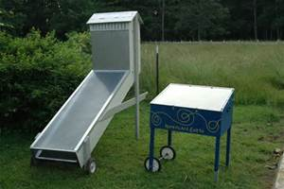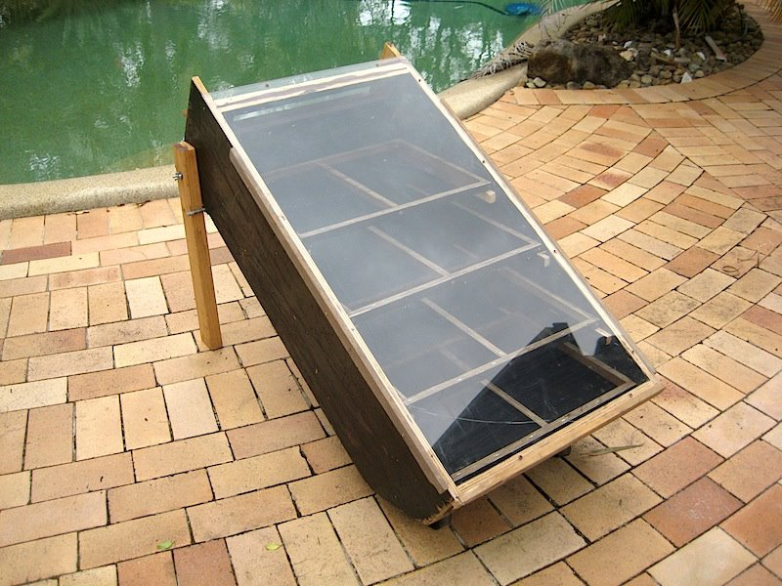
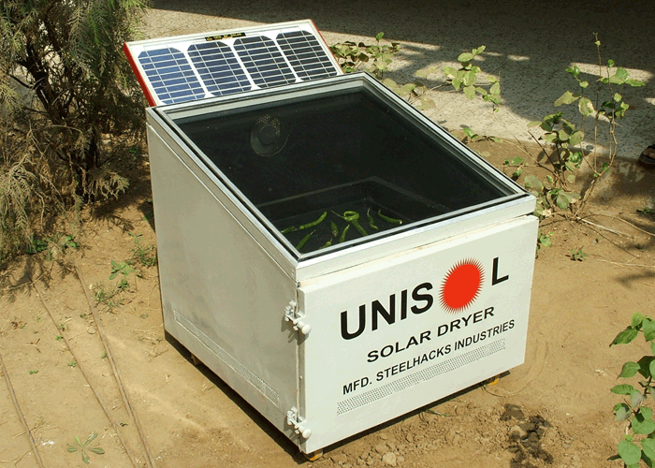
https://www.youtube.com/watch?v=-1cZPdauq-Q
https://www.youtube.com/watch?v=YbZvYLzfjJo
https://www.youtube.com/watch?v=G99QTFcq258
https://www.youtube.com/watch?v=PU8Pz7NFAxg
https://www.youtube.com/watch?v=Nf8BUfV_Th0
http://www.gardeningknowhow.com/edible/vegetables/tomato/drying-tomatoes.htm
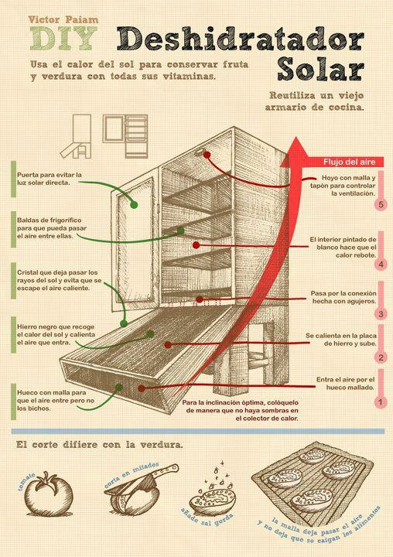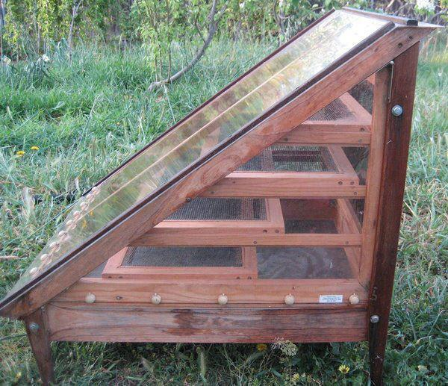
http://www.labioguia.com/como-hacer-un-deshidratador-solar/
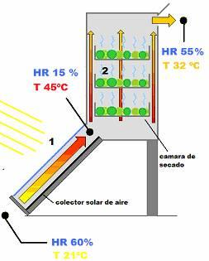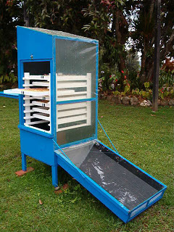http://www.elcorreodelsol.com/articulo/construir-un-deshidratador-solar
http://www.ecototal.com/autosuficiencia/559-secadero-solar-casero-
http://www.veoverde.com/2014/08/niwa-la-app-que-puede-controlar-un-pequeno-invernadero-dentro-de-tu-casa/
http://www.gastronomiaycia.com/2013/04/28/doce-recetas-con-tomates-secos/
http://www.lacocinaalternativa.com/libro-de-recetas/
En inglés ( principalmente en you tube )
http://www.pickyourown.org/tomatoes_sun_dried.htm
http://efooddehydrator.com/
http://homecooking.about.com/od/howtocookvegetables/a/sundriedrecipe.htm
https://www.youtube.com/watch?v=NUlTFWUvhkU
https://www.youtube.com/watch?v=YbZvYLzfjJo
https://www.youtube.com/watch?v=9NbvI6OR8R8
https://www.youtube.com/watch?v=B19-VZkaMN8
https://www.youtube.com/watch?v=MVPZ9bUkrdA
https://www.youtube.com/watch?v=CnyLVMo6ImI
https://www.youtube.com/watch?v=ZrwMonV0z6g
https://www.youtube.com/watch?v=Ys7wl7CUR1U
http://www.wisegeek.com/what-is-a-food-dehydrator.htm#didyouknowout
http://www.thefreelibrary.com/Simultaneous+infrared+dry+blanching+and+dehydration+for+fruits+and...-a0161846912
http://www.thefreelibrary.com/Publications/A-i1
http//:ceeldorado@ucdavis.edu
http://anrcatalog.ucdavis.edu/pdf/8116.pdf
http://homecooking.about.com/od/howtocookvegetables/a/sundriedrecipe.htm
http://www.gardeningknowhow.com/edible/vegetables/tomato/drying-tomatoes.htm
http://ucanr.edu/sites/scmg/The_Kitchen_Garden/?story=654
http://www.tomatodirt.com/drying-tomatoes.html
http://www.gardening-tips-idea.com/Drying-tomatoes.html
http://organicgardening.about.com/od/vegetablesherbs/a/driedtomatoes.htm
http://www.seasonalchef.com/tomdehyd.htm
http://rvpadmin.cce.cornell.edu/pdf/submission/pdf217_pdf.pdf tratamiento enfermedades http://www.allotment-garden.org/vegetable/tomato/types-tomatoes.php
http://www.ivia.es/documentos/objetivosproyectos/ruralcaja/pdfs-ensayos/T1.pdf

Français
http://www.ptitchef.com/entraide/comment-secher-les-tomates-qid-4087
http://www.fao.org/docrep/S6570F/S6570F00.gif
http://www.fao.org/docrep/S6570F/S6570F01.htm
http://www.750g.com/tomates-farcies-r146.htm
Italiano
www.agromeccanica.com/web_ita/linea_pomodoro.html
http://cuciniere.blogspot.com.es/2007/08/conserva-di-pomodori.html
http://www.tesionline.it/default/tesi.asp?idt=21755
http://www.tesionline.it/consult/indice.jsp?pag=1&idt=21755

