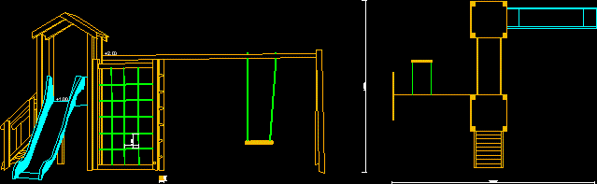
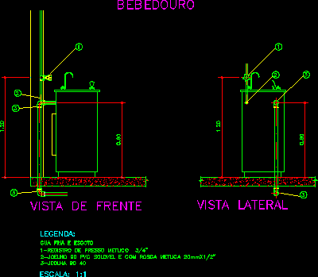
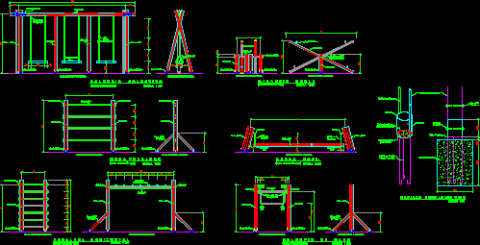
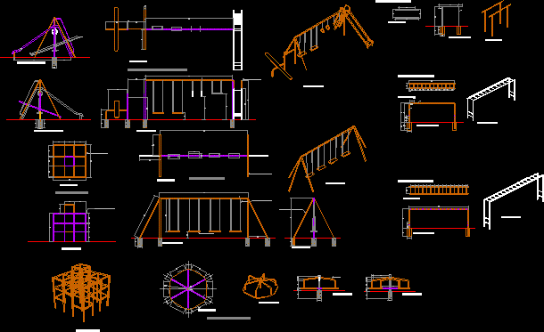
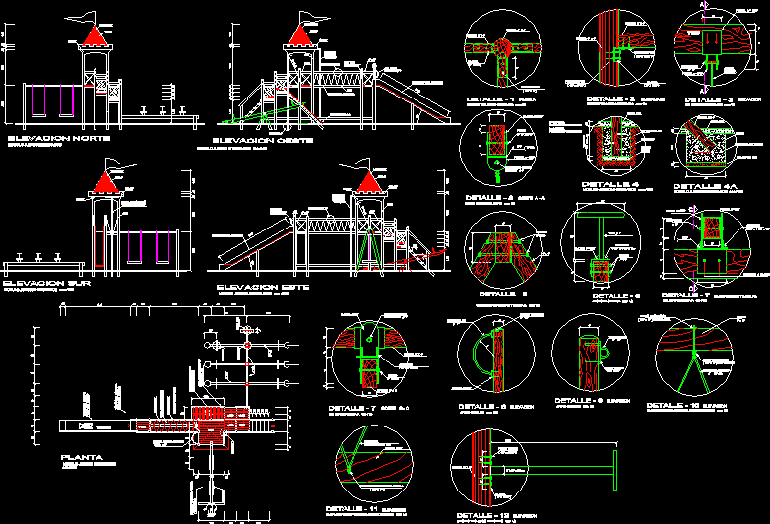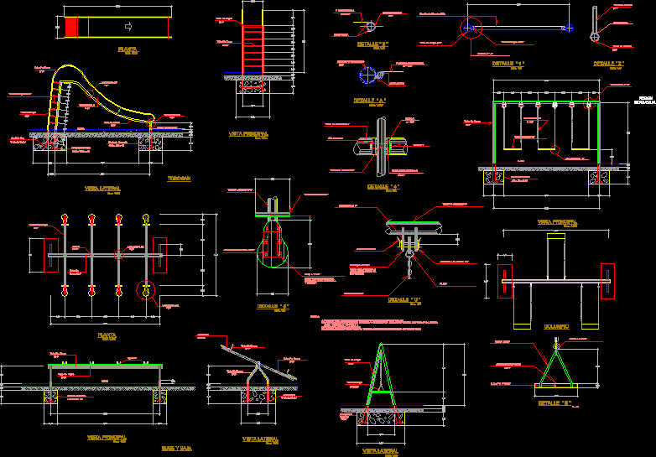
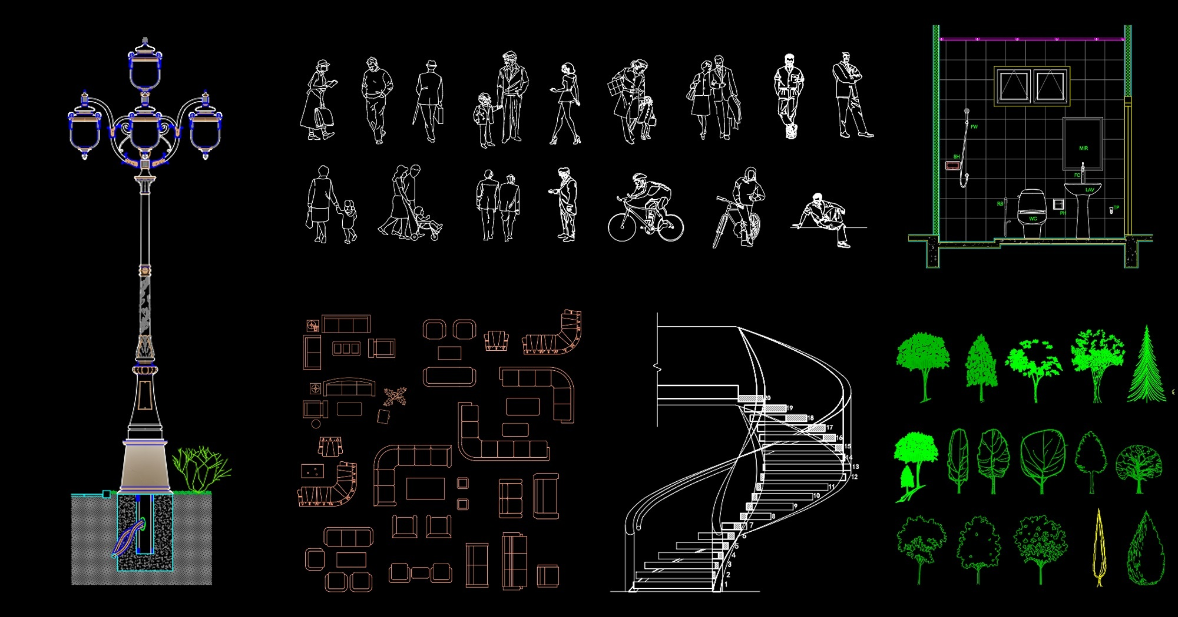

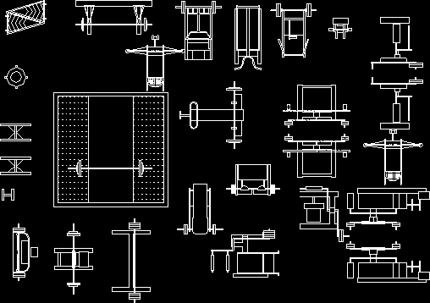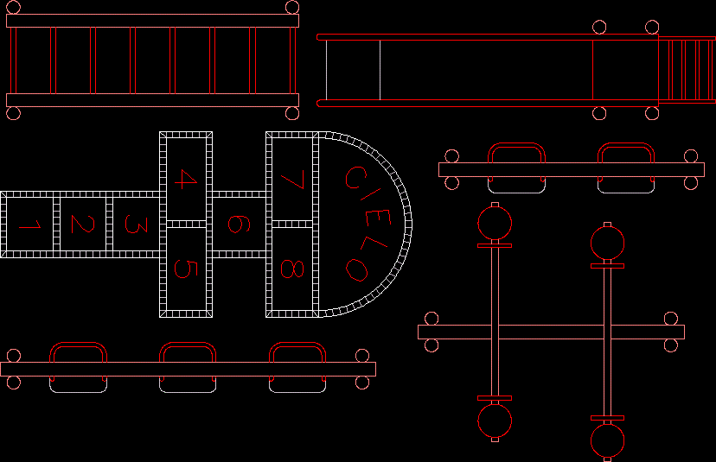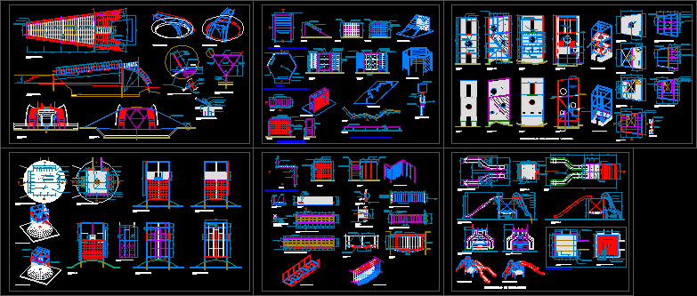
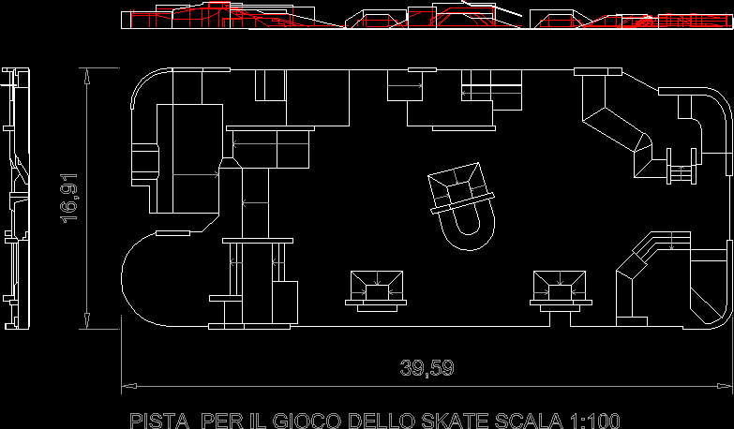
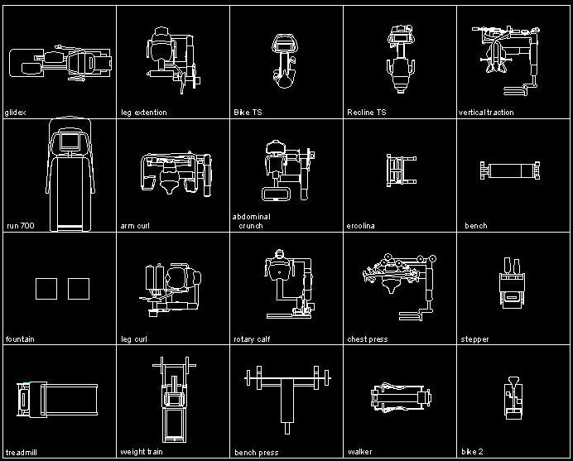
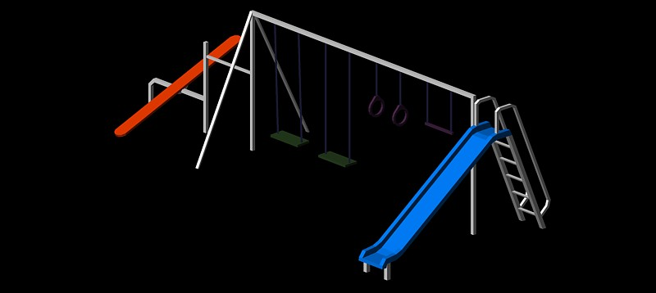
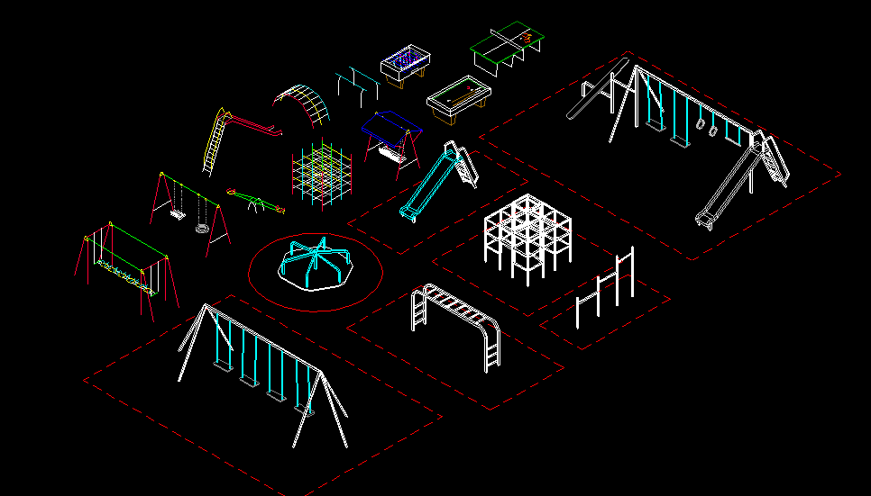
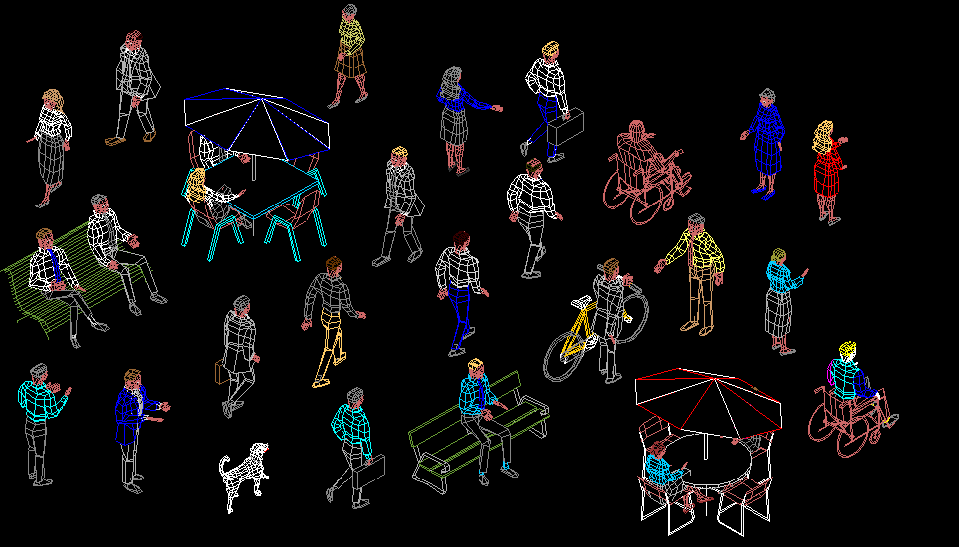
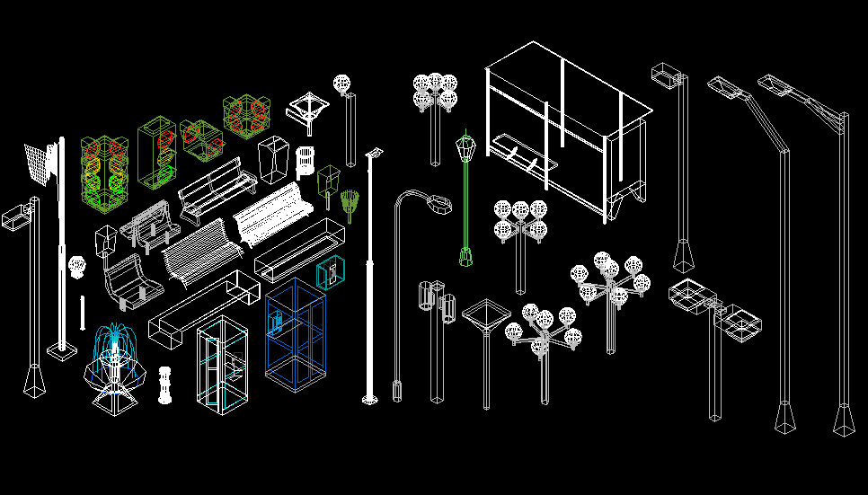
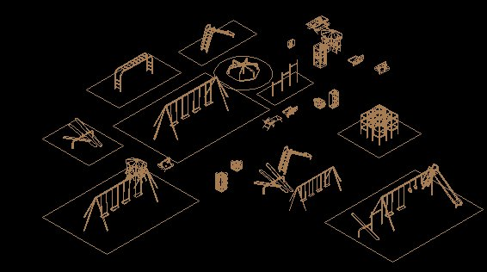
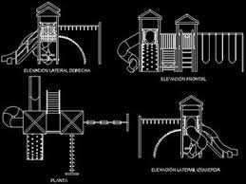
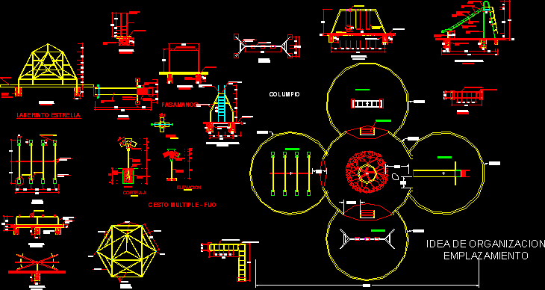
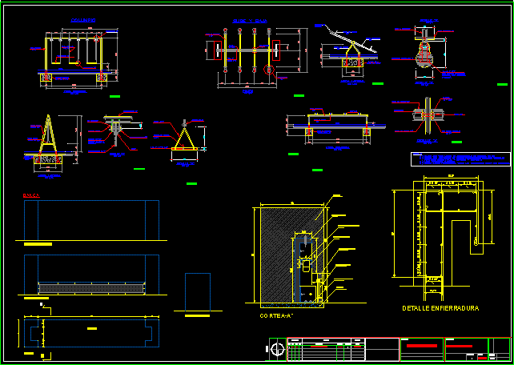http://www.zjfeiyou.com/products.html
http://www.zjfeiyou.com/Catalog/index.html
https://www.thebalance.com/free-playhouse-plans-1357134 Numerosos planos de juegos para niños, por ejemplo los siguientes
- https://www.thebalance.com/free-tree-house-plans-1357144
- http://www.todaysplans.net/GeorgiaPacific-Garden-Shed-Project-Plan.pdf
- https://www.thebalance.com/free-chicken-coop-plans-1357113

https://morningchores.com/playhouse-plans/
https://www.pinterest.es/explore/planes-de-casa-de-juegos/?lp=true
https://www.pinterest.es/pin/396387204681909874/ casas de muñecas
https://www.builddirect.com/blog/8-free-plans-for-playhouses/
http://www.ana-white.com/2010/05/furniture-plans-playhouse-front-wall-options-and-doors.html
http://www.ana-white.com/category/plans/project-type Montón de proyectos
https://morningchores.com/playhouse-plans/
http://shedplan247.blogspot.com.es/2013/06/how-to-build-shed-on-skids.html?m=1
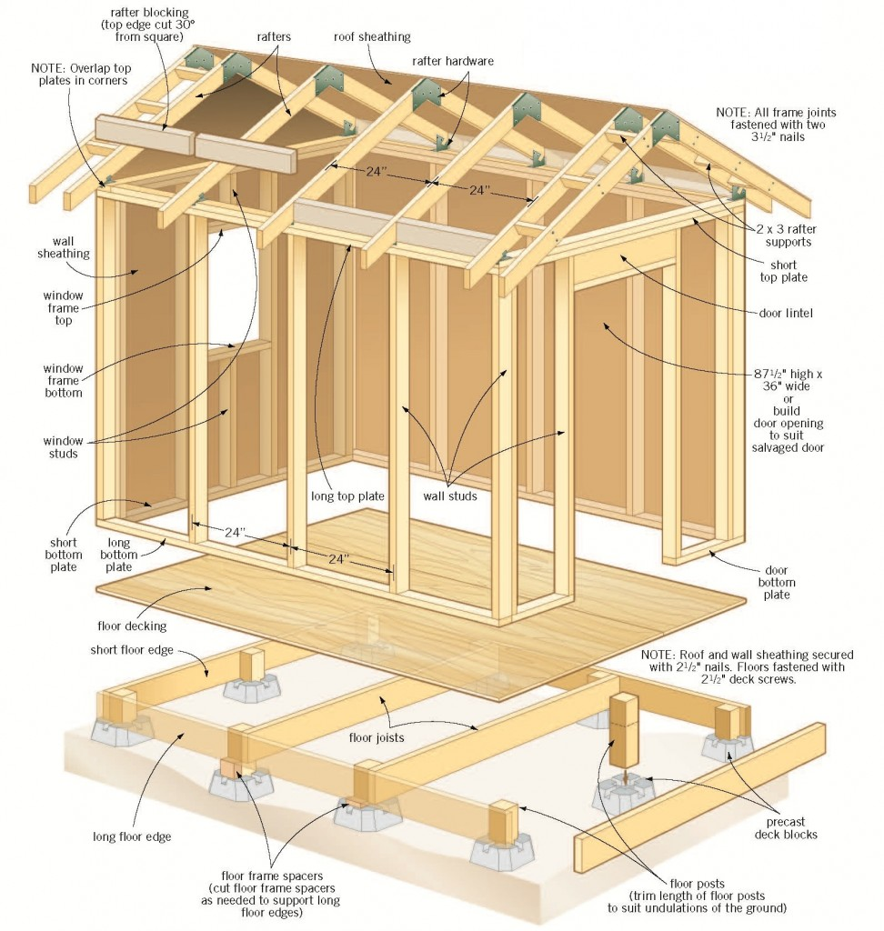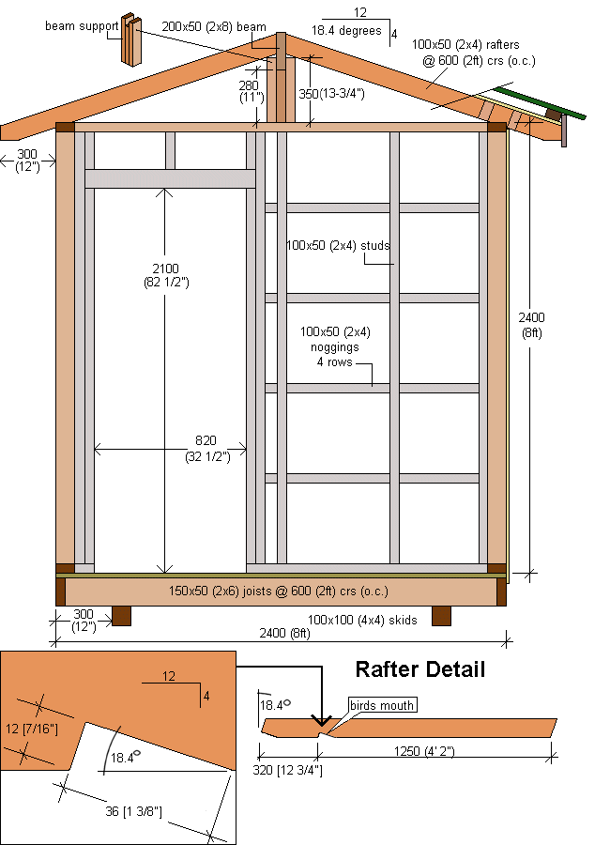
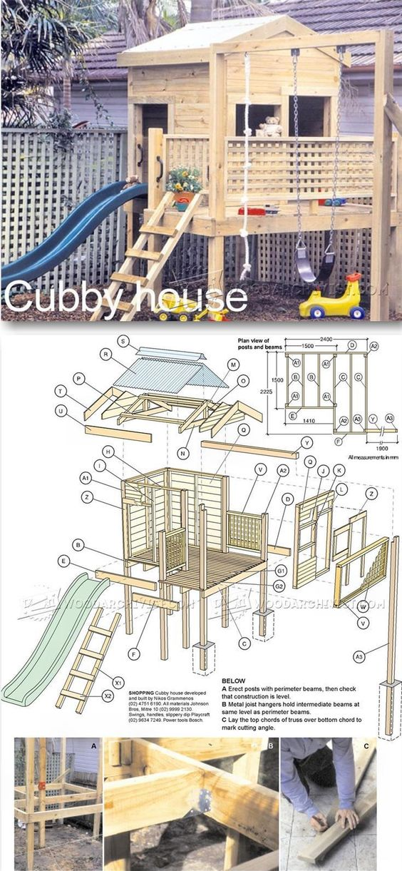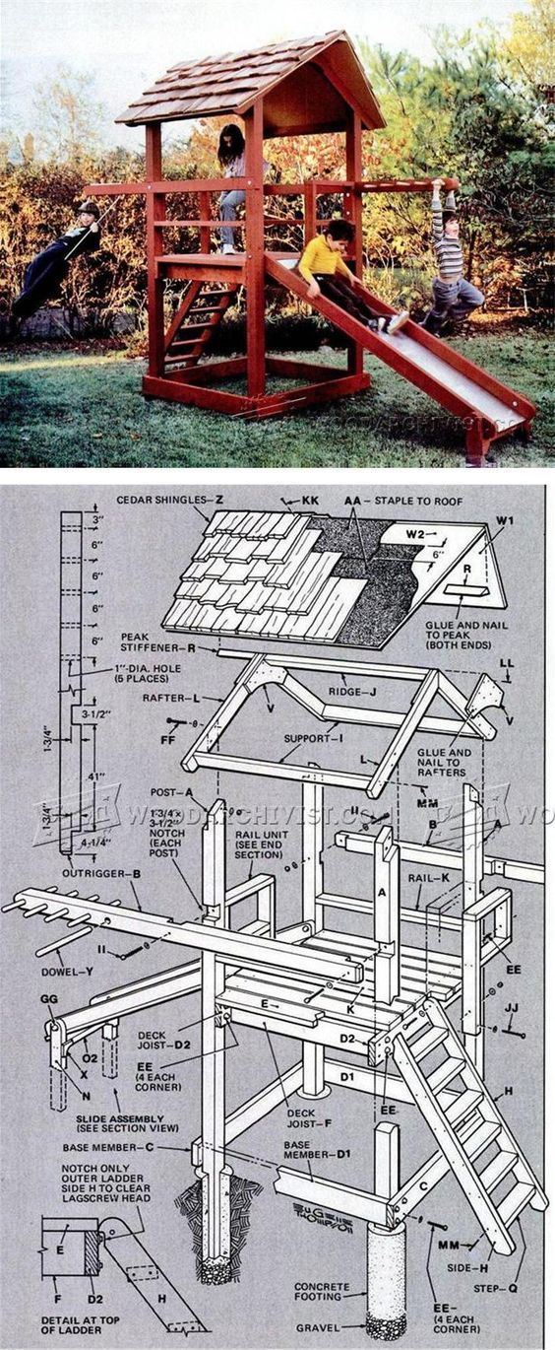https://www.pinterest.co.uk/pin/480055641516249403/
https://toolcrib.com/blog/2009/03/25-free-backyard-playground-plans-for-kids-playsets-swingsets-teeter-totters-and-more/
http://www.indoorplaygroundschina.com/?gclid=EAIaIQobChMI8eDYzoO62QIVjBbTCh3aag1sEAAYAiAAEgKyq_D_BwE Equipos interiores
para colorear
http://www.kidsgetaplan.com/thirtyrule.php Juegos instructivos para niños, evitar peligro
https://www.pinterest.cl/pin/543598617509746534/
Indian tents plans imágenes de tiendas indias

