http://i-mar2.cl/wp-content/uploads/2017/04/2010-Chopin-et-al-DIFUSION-Parte-1.pdf
https://www.youtube.com/watch?v=UCtAQOP3xuk
http://www2.unb.ca/chopinlab/articles/index.html
http://www.fojo.org/papers/deposit/Cubillo%20et%20al%202015%20IMTA%20deposit%20feeders.pdf
file:///C:/Users/fabregas/Dropbox/Downloads/Integrated_multi-trophic_aquaculture%20(1).pdf
http://ecoaqua.ulpgc.es/sites/default/files/documentos/Summerschool/Presentations/IMTA%20EcoAqua%20Summer%20School%20.pdf
https://link.springer.com/referenceworkentry/10.1007%2F978-1-4614-5797-8_173#page-1
http://www.idreem.eu/cms/what-is-imta/
http://www.idreem.eu/cms/wp-content/uploads/2013/05/AbreuETAL_ISS2013Bali.pdf
http://www.idreem.eu/cms/wp-content/uploads/2016/10/IDREEM_FINALREPORT_PRINT_710_web_2.pdf
https://ec.europa.eu/maritimeaffairs/sites/maritimeaffairs/files/docs/body/com_2012_494_en.pdfhttps://ec.europa.eu/maritimeaffairs/sites/maritimeaffairs/files/docs/body/com_2012_494_en.pdf
file:///C:/Users/fabregas/Dropbox/Downloads/283886.pdf
http://www.sciencedirect.com/science/article/pii/S2211464515000305
http://www.mapama.gob.es/es/ministerio/servicios/publicaciones/j_otras_politicas_tcm7-347418.pdf
http://oaji.net/articles/2016/1276-1465311664.pdf
http://www.fao.org/3/a-i4626e.pdf
https://addi.ehu.es/bitstream/handle/10810/22626/TESIS_BADIOLA_AMILLATEGUI_MADDI.pdf?sequence=1&isAllowed=y
https://www.slideshare.net/pierluigisilvacorrea/tratamiento-terciario-de-aguas-residuales-desinfeccion
https://www.eaurmc.fr/espace-dinformation/guides-acteurs-de-leau/lutter-contre-la-pollution-domestique/traitement-domestique.html?eID=dam_frontend_push&docID=735
https://epnac.irstea.fr/wp-content/uploads/2017/08/CPA2017_Zones-rejets-vegetalisees.pdf
https://epnac.irstea.fr/wp-content/uploads/2015/08/ZRV-HYDROPLUS-01-2014.pdf
https://epnac.irstea.fr/wp-content/uploads/2015/10/20151009_Cahier-des-charges-des-ZRV_EPNAC_2015.pdf
http://www.set-revue.fr/sites/default/files/articles/pdf/macrophytes-epuration-eaux-usees-SET-revue.pdf
http://www.cms-habiter.eu/SMS/Revue%20de%20projet%202/Recherches/Les%20eaux/Textes%20references/Lassainissement%20ecologique%20des%20eaux%20usees%20domestiques.pdf
http://www.wikiwater.fr/a20-les-filtres-plantes-de.html
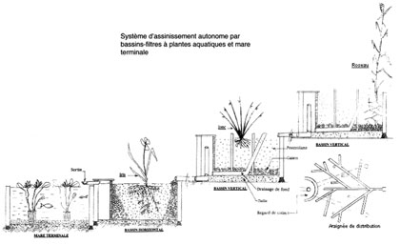
http://data.over-blog-kiwi.com/0/93/91/74/20140604/ob_9062ca_dossier-presse-aquatiris-20143.pdf

